BUG REPORT

CURA Healthcare Services

|  |  |  |
| --- | --- | --- |
| Bug Id | Description | Severity |
| TC-23 | Visit date should not accept  invalid dates rather display error  message to enter valid date | Major |
| TC-24 | Comment section should accept numbers, special characters, audio, Video along with Normal text. | Minor |
| TC-28 | Profile should contain basic  details of user | Major |
| TC-33 | Application should contain a Text box to Enter Email-id, for getting application related Notifications as Account confirmation, Password Reset, Username, Password recovery any other related Emails. | Major |
| TC-34 | Application should contain Forgot Password feature to Reset Password as and when required. | Major |

Test case Id - TC-23

Steps to Reproduce

1. Open Application URL https://katalon-demo-cura.herokuapp.com/
2. Login to the Account with valid Username, Password
3. Enter Invalid Date into “Visit Date” Field. (eg. 35/14/2001)

Expected Result

Visit date should not accept Invalid dates rather display error message to enter valid date

Actual Result

There is no error message for invalid entry and date field reset invalid date with valid date randomly

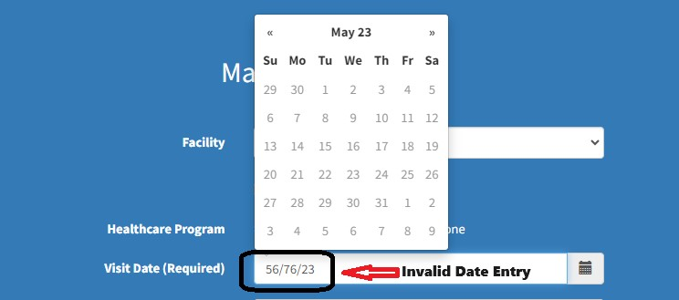

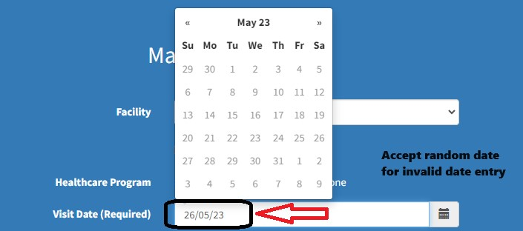

Test case Id - TC-24

Steps to Reproduce

1. Open Application URL https://katalon-demo-cura.herokuapp.com/
2. Login to the Account with valid Username, Password
3. Enter Normal Text, Image link, Audio and Video link

Expected Result

Comment section should accept numbers, Special characters, Audio, Video along with Normal text.

Actual Result

Comment section accepts audio, image link, Video links but are mentioned in link format and on clicking on them will not open or respond that links.

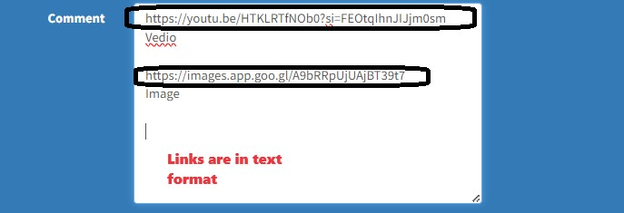

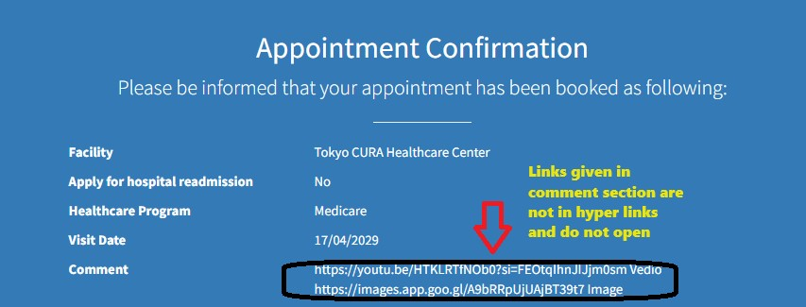

Test case Id - TC-28

Steps to Reproduce

1. Open Application URL https://katalon-demo-cura.herokuapp.com/
2. Login to the Account with valid Username, Password
3. Make Appointment by giving values to all fields
4. Click on Profile on top right corner three lines

Expected Result

Profile should contain basic details of user.

Actual Result

Profile has no basic details of User "Under Construction" message is displayed

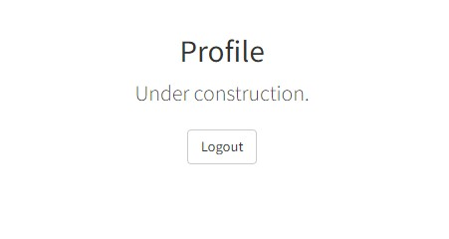

Test case Id - TC-33

Steps to Reproduce

1. Open Application URL https://katalon-demo-cura.herokuapp.com/
2. Enter Email-id (The feature is missing)
3. Login to the Account with valid Username, Password

Expected Result

Application should contain a Text box to Enter Email-id, for getting application related Notifications as Account confirmation, Password Reset, Username, Password recovery any other related Emails.

Actual Result

Email-id Feature is not present in the Application.

Test case Id - TC-34

Steps to Reproduce

1. Open Application URL https://katalon-demo-cura.herokuapp.com/
2. Enter Email-id (The feature is missing)
3. Forgot Password Feature Missing

Expected Result

Application should contain Forgot Password feature to Reset Password as and when required.

Actual Result

Forgot Password Feature is not present in Application.